**SPRINT 3**

**PRODUCT ANALYSIS**

**Which Product is Sold and When (Seasonal Analysis)**

**Graph-1**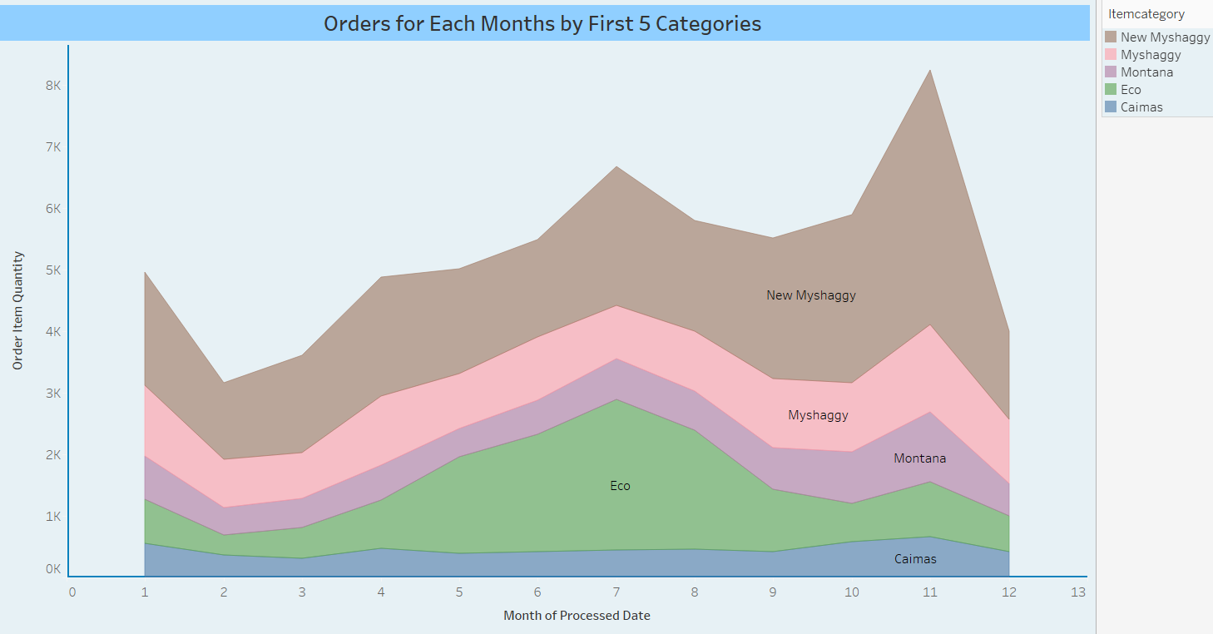

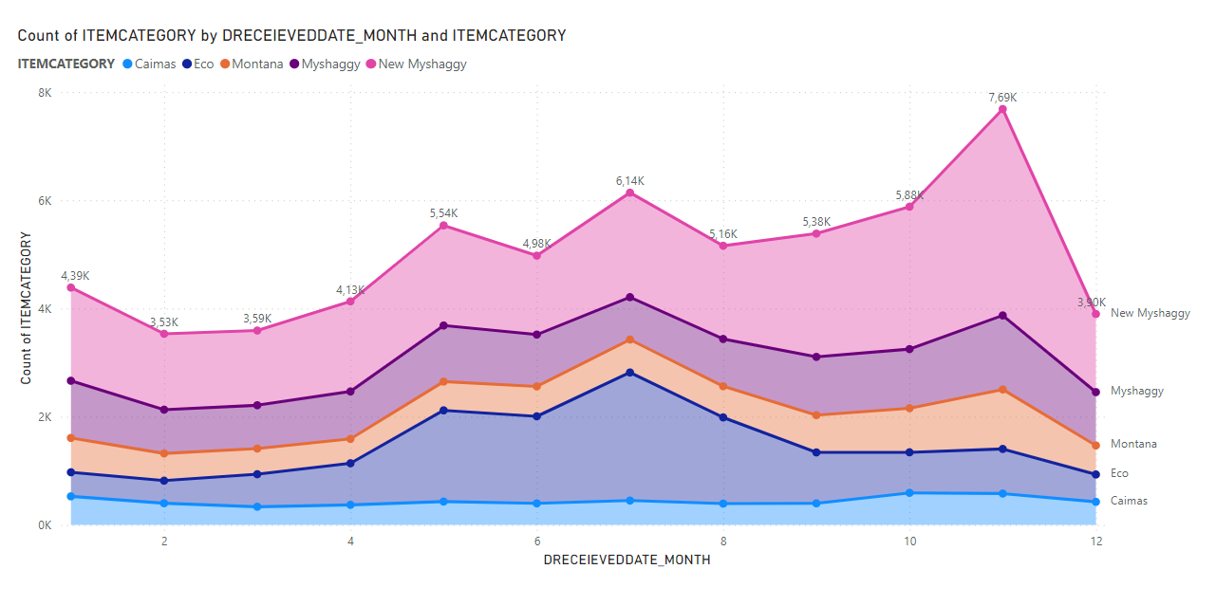

In this analysis, five best-selling products were examined. When the 5 best selling seasonal products are examined, it is seen that the sales trend of the product “Caimas” increased in September, peaked in November and started to decline in December.

When we look at the "New Myshaggy" in the first row, it is observed that there is a decrease from January to February, but there is a rise from February to July, there is a decrease in July-August, but a sharp upward trend is observed again from September. It is understood that this situation is the same for the products in the 2nd, 3rd and 4th rows.

**Graph-2**

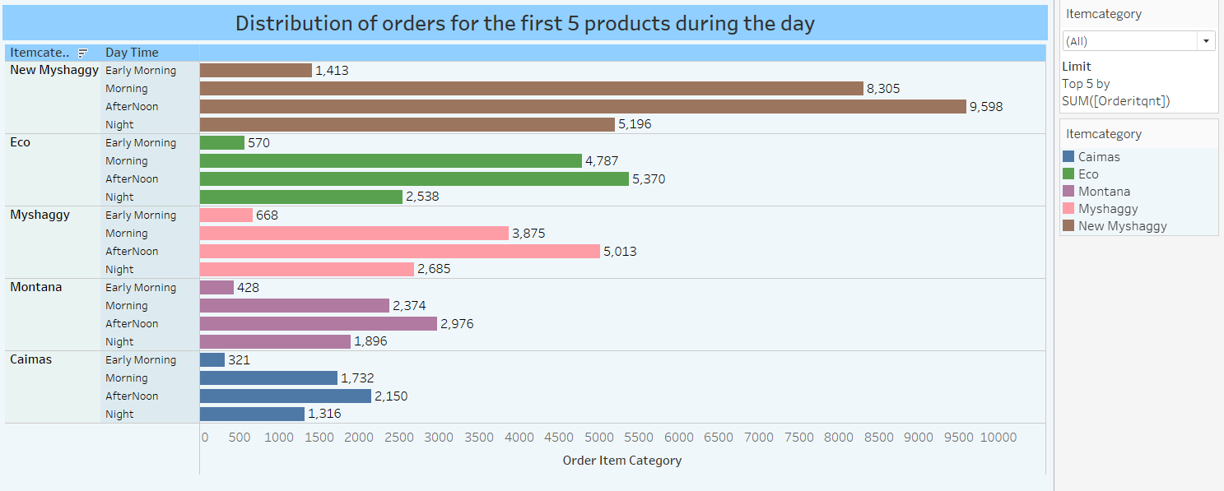

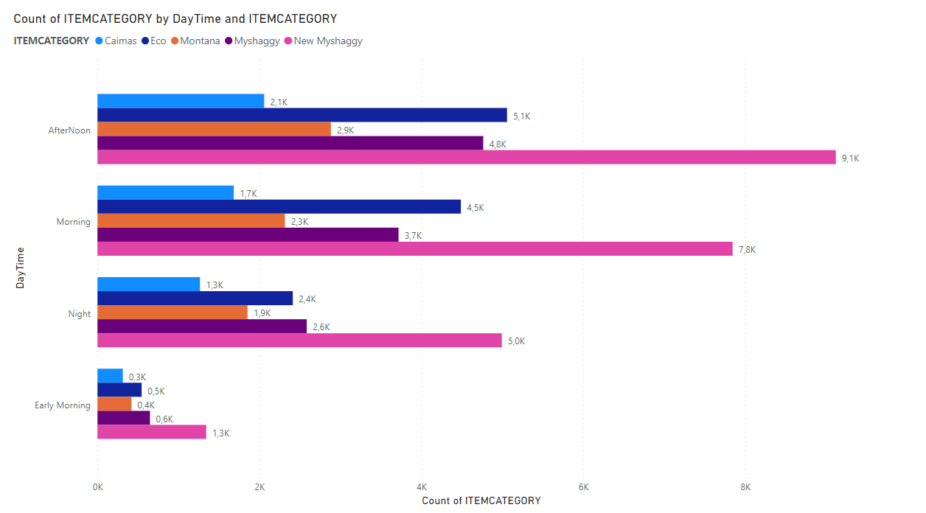

When the products in the first 5 categories are examined in which time period during the day; it is seen that the most sales are made in the afternoon, in the morning, in the evening and in the early morning, according to the order.

**2. Which Product is Sold on Which Platform and How Many?**

**Graph-1**

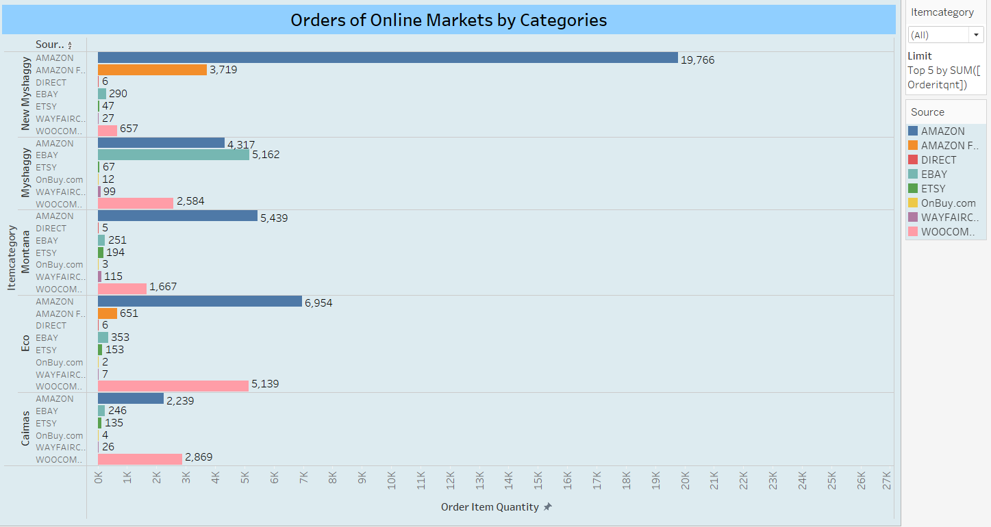

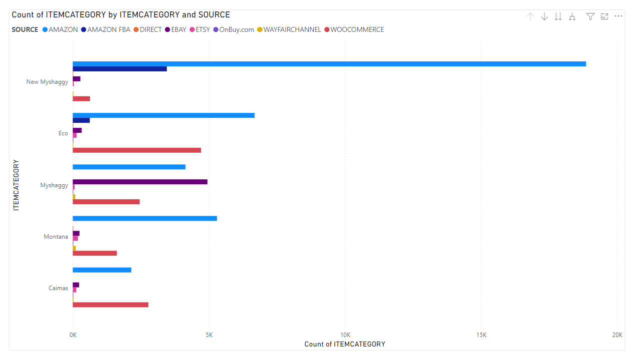

When the 5 best-selling products in the product category are examined, it is seen that the best-selling “New Myshaggy” is sold on Amazon, “Mysaggy” in the 2nd place is sold on EBAY, Montana in the 3rd place and Eco in the 4th place, in the 5th place and in the Amazon. It is seen that the “Caimas” type is sold at Woocommerce.

According to these results, the following can be said, the sales of each product on online platforms may differ.

**3. Analysis of Returned Products and Reasons for Returns**

**Graph-1**

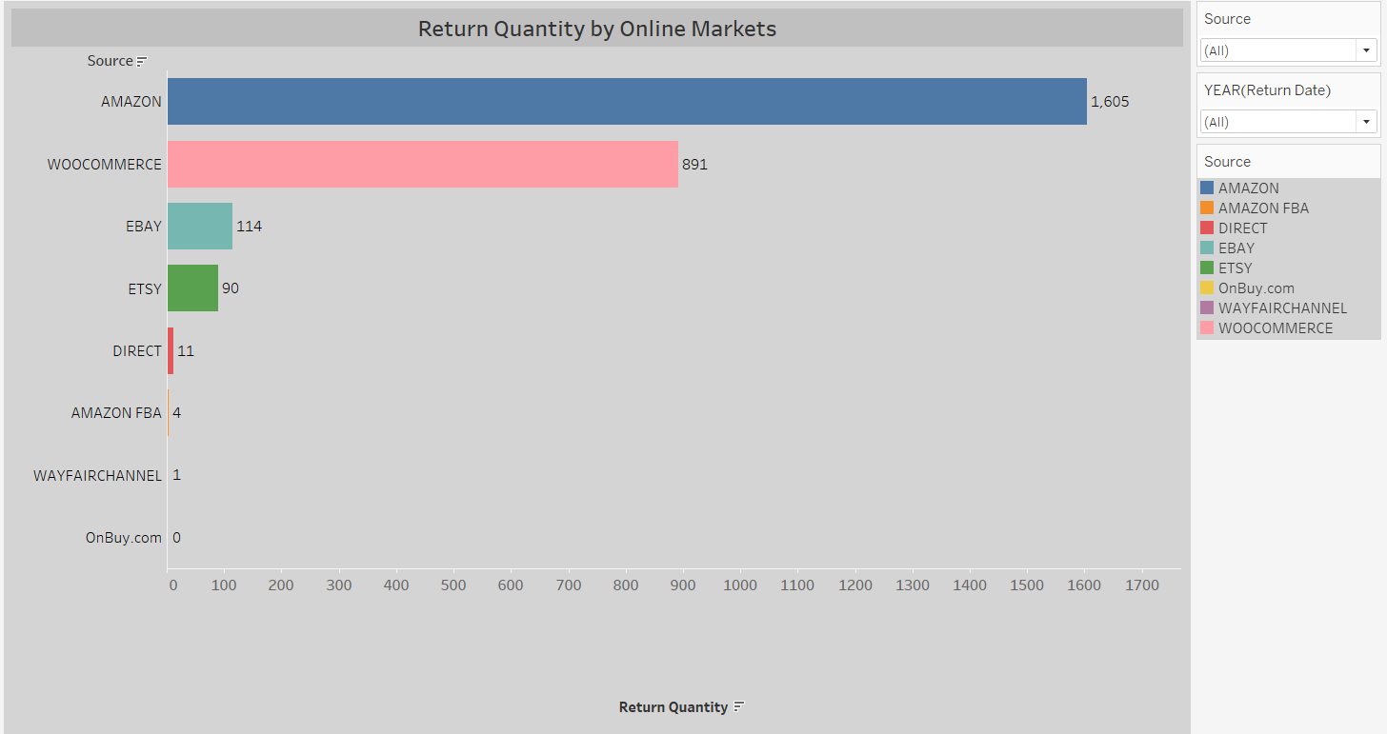

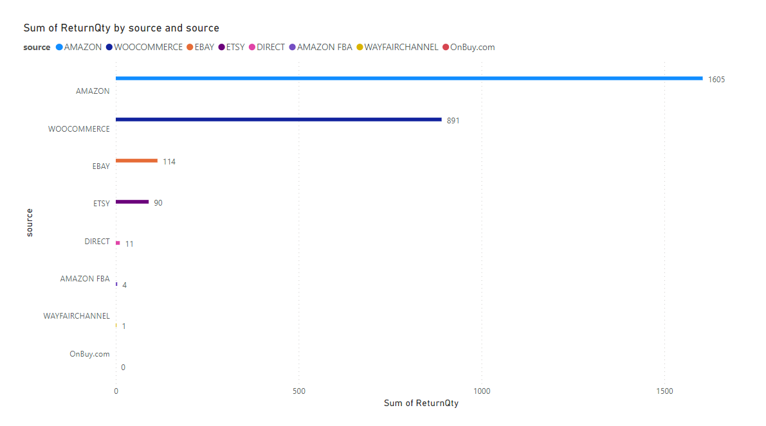

It is seen that the most returned products are from Amazon and then from Woocommerce. It is understood that this result is directly proportional to the orders received from online platforms.

**Graph-2**

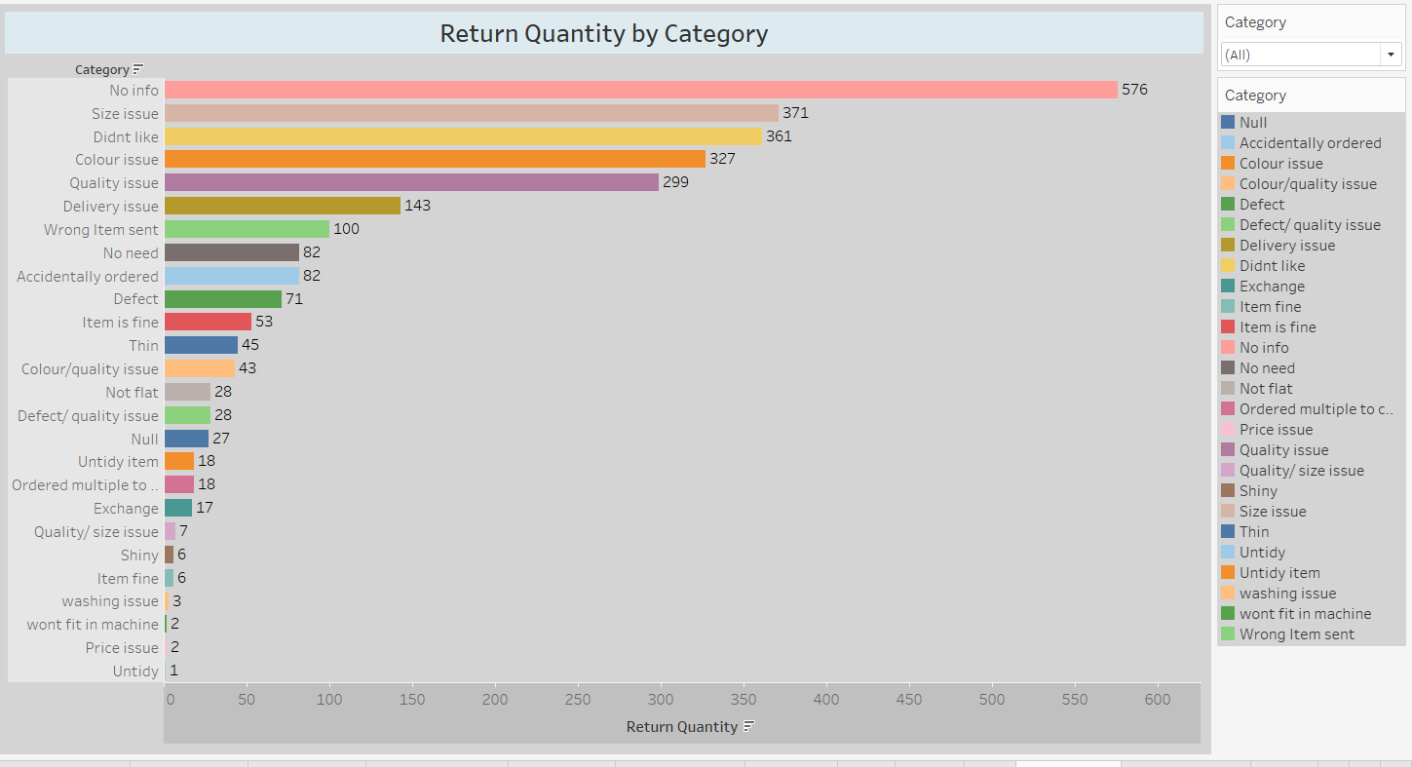

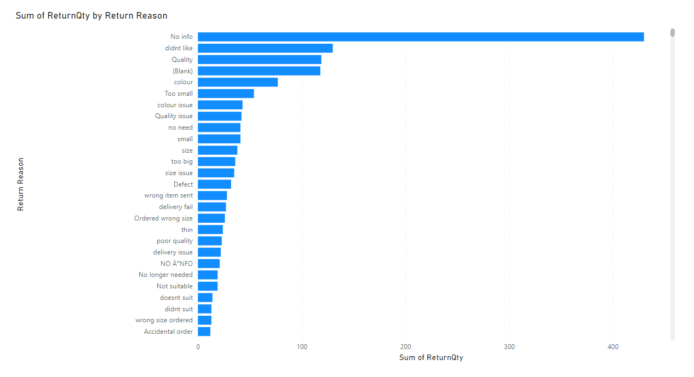

Considering the number and justifications of the returned products, the customer returned the first 576 products without giving any reason. 2. The customer returned 361 items in the order due to the size of the product. 3. If the next 327 items are returned, the product was made because the product was not liked. Returns in the 4th, 5th and 6th rows were made due to quality, color and distribution problems.

Regarding these results, water can be said; The customer can return the product for different reasons. Therefore, the seller should review the accuracy of the product information and the ability of the images to reflect the product in order to ensure customer satisfaction. Every stage of online sales should be done with care and customer relations should be well managed.

**Graph-3**

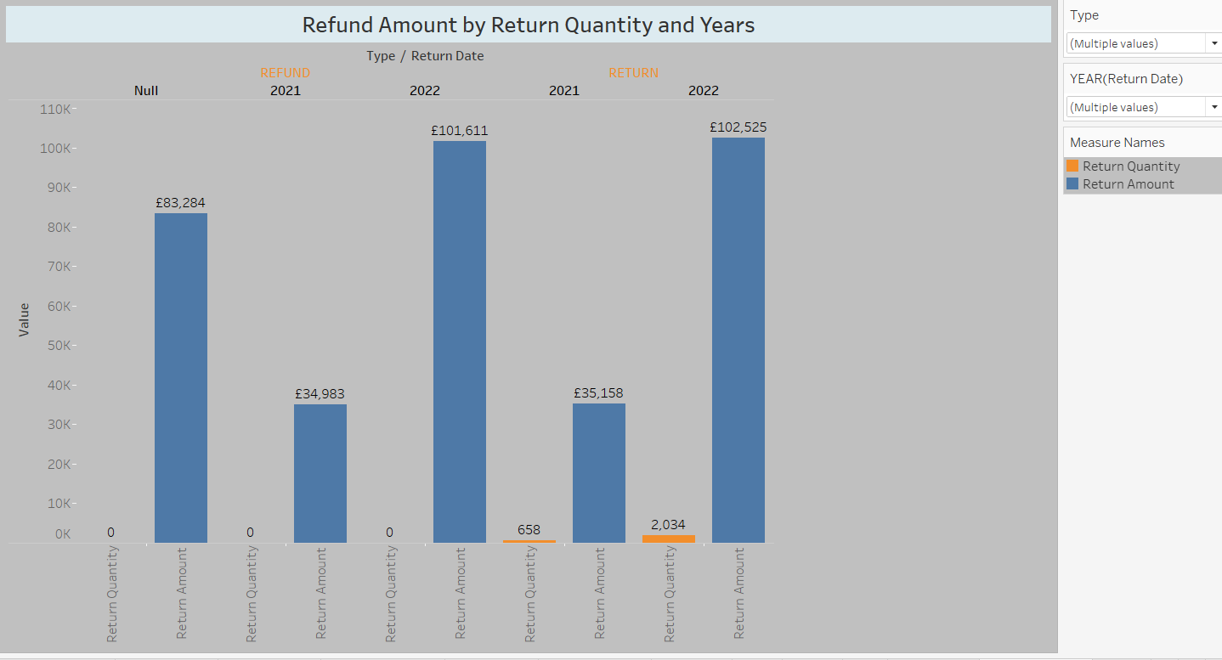

When the types of returned products are examined by years, it is seen that the refund amount in the years 2021 and 2022 is 101611 £ and the year 2022 at the most, in an unspecified year.

When the return status of return type products is examined, it is seen that 658 products were returned in 2021 and 2034 products in 2022. It is understood that these returns are directly proportional to the year in which the turnover is made.

Note: In Dataset, if the type of returned products is non-refundable, the return quantity is zero(0).

**Graph-4**

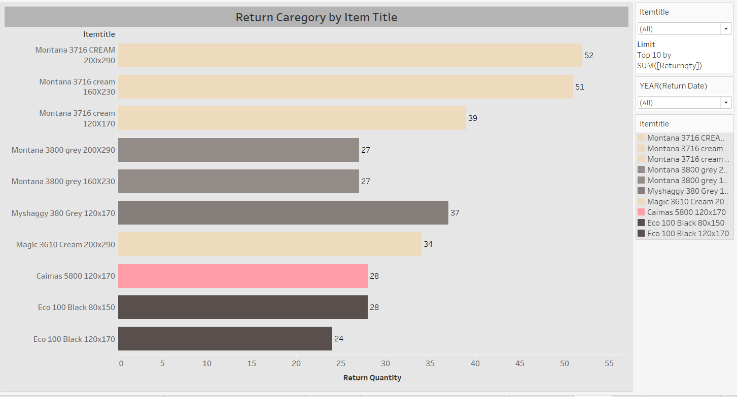

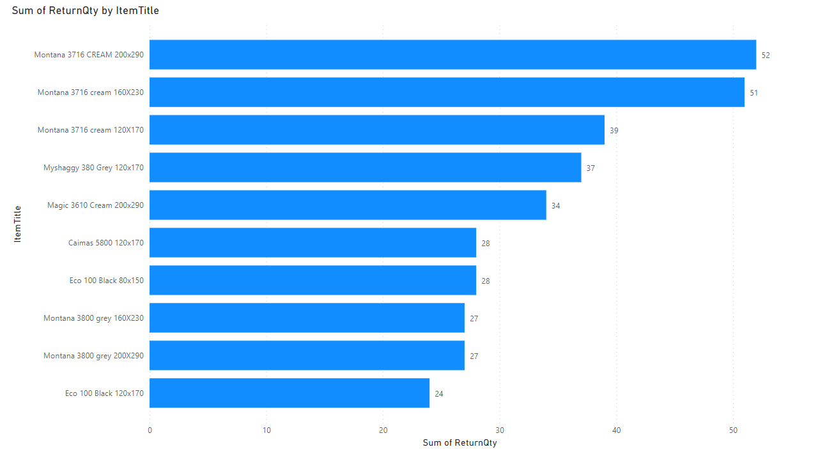

When the 10 most returned product categories are examined, it is seen that the large sizes (120x170, 160x230 and 200x290) of the Montana3716 cream and Montana 3800 gray categories are returned.

When the other returned categories are examined, it is seen that cream, gray and black colors are returned.

It is considered that it would be beneficial for the company to review the sales of these color products.

**Graph-5**

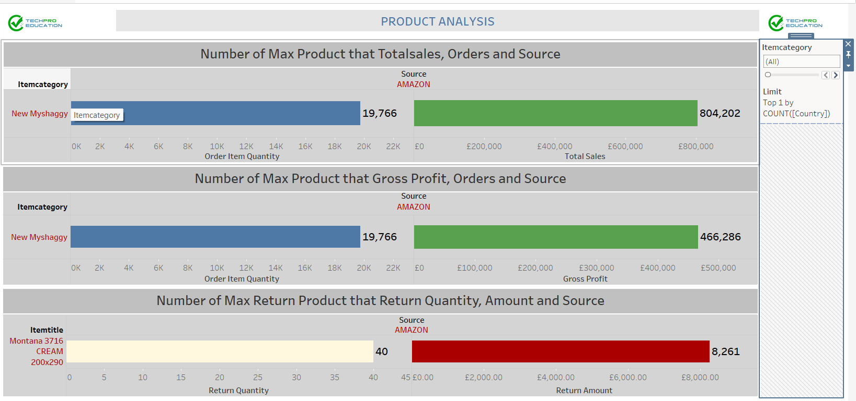

It is seen that 19766 units were sold from the amazon platform in the “New Myshaggy” tour, with a total turnover of 466286 pounds.

It is seen that the highest gross profit was obtained from the “New Myshaggy” category sold on amazon and £466286.

It is understood that the most returns from the products are made in the size of “Montana 3716 cream 200x290” and the cost of this is £ 8261.

**Market Basket Analysis with Apriori**

What is Apriori?

Apriori is a popular algorithm for extracting frequent itemsets with applications in association rule learning. The apriori algorithm has been designed to operate on databases containing transactions, such as purchases by customers of a store. An itemset is considered as "frequent" if it meets a user-specified support threshold. For instance, if the support threshold is set to 0.5 (50%), a frequent itemset is defined as a set of items that occur together in at least 50% of all transactions in the database.

In the shopping made in 2022, we selected the customers who bought more than one product. 1641 different products have been added to the basket in 2570 different shopping.

­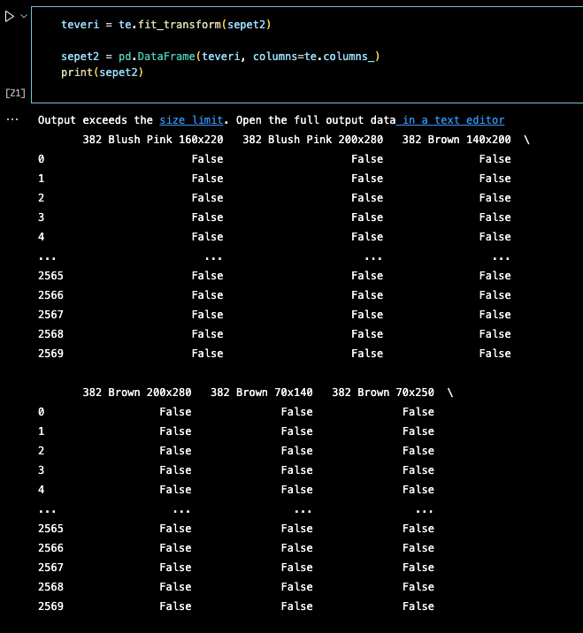

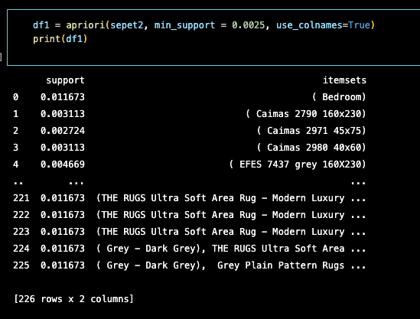

We selected the minimum support value as 0.0025 and the minimum threshold of our confidence metric as 0.25. And we got the following results:

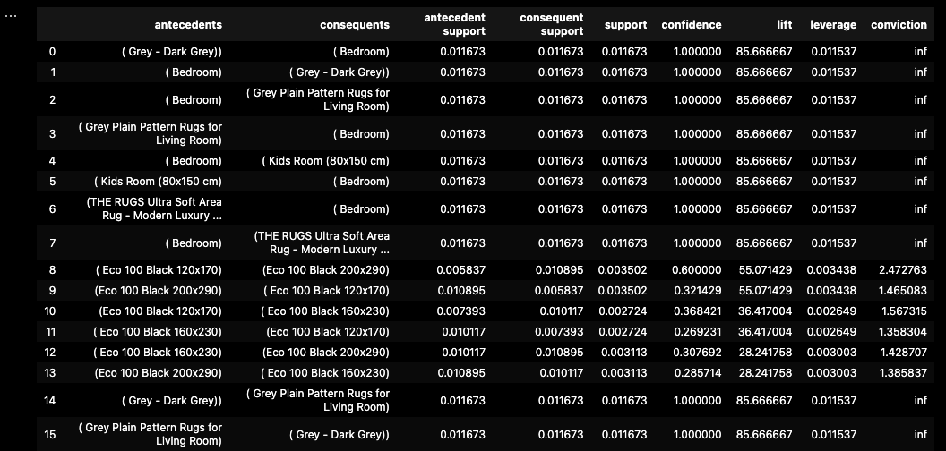

We achieved the same result by using FP-Growth instead of Apriori. FP-Growth runs 6x faster.

In general, the algorithm has been designed to operate on databases containing transactions, such as purchases by customers of a store. An itemset is considered as "frequent" if it meets a user-specified support threshold. For instance, if the support threshold is set to 0.5 (50%), a frequent itemset is defined as a set of items that occur together in at least 50% of all transactions in the database.

In particular, and what makes it different from the Apriori frequent pattern mining algorithm, FP-Growth is an frequent pattern mining algorithm that does not require candidate generation. Internally, it uses a so-called FP-tree (frequent pattern tree) datastrucure without generating the candidate sets explicitely, which makes is particularly attractive for large datasets.

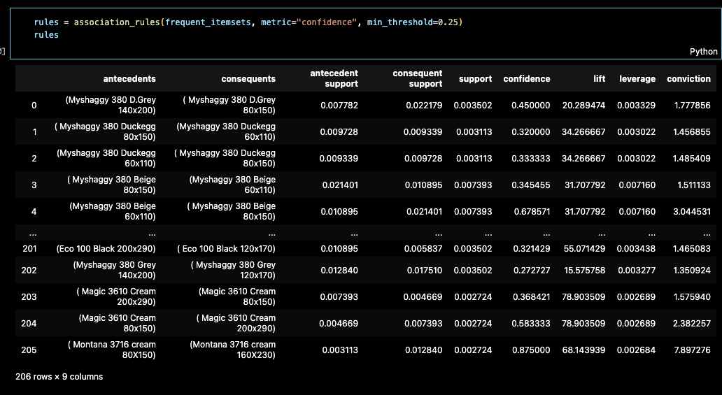

We read the table as:

Probability of getting (Myshaggy 380 D.Grey 140x200) product : **0,007782** [antecident support]

Probability of getting (Myshaggy 380 D.Grey 80x150) product: **0,022179** [consequent support]

Probability of getting both: **0,003502** [support]

The probability that the second will be added to the basket when the 1st is bought: **0,45** [confidence]

**1.Data Set Preparation**

The pre-trained YOLOV5 model was chosen to set up this machine learning model. The main reason for using this model is that it is stable and easy to set up compared to many Computer Vision models**.**

First, the carpet pictures were grouped as 30 pictures for each color group from the-rugs.com website. The main purpose here was to create an object detection model based on the state colors.

There were about 14 color categories for different types of carpet models on the web-site.

These are:

* + - Beige
    - Black
    - Blue
    - Brown
    - Duck Egg
    - Green
    - Grey
    - Multicolor
    - Orange
    - Pink
    - Purple
    - Red
    - White
    - Yellow

But in these color categories; There was not enough carpet model on sale to train our model. In this context, it has been determined that the Yolo object detection model can be used to detect the color of different objects other than carpets. Objects other than carpet, such as car, pen, etc. defined by color in to the YOLOV5 model. Insufficient data in the dataset has been there by completed.

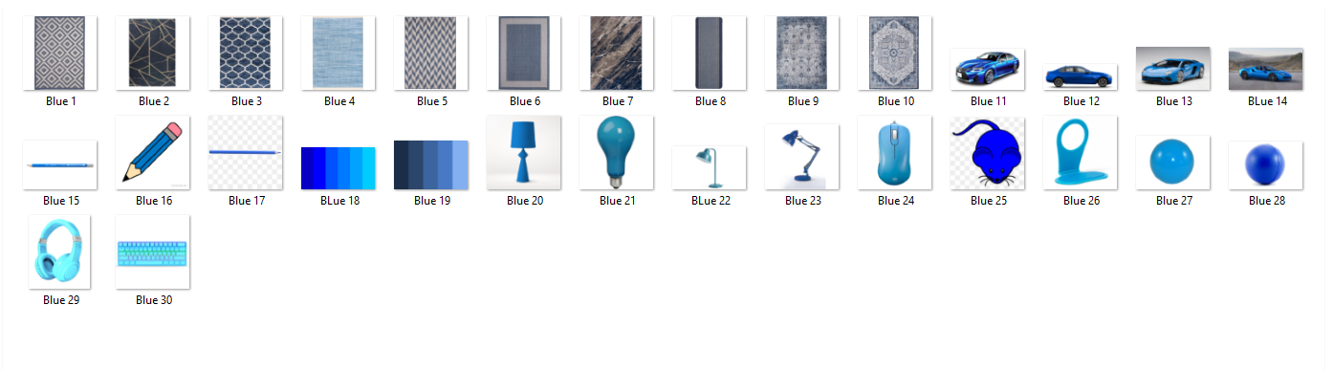

After reaching the sufficient number of images for the model in the data set, the images were labeled via makesenai.com.

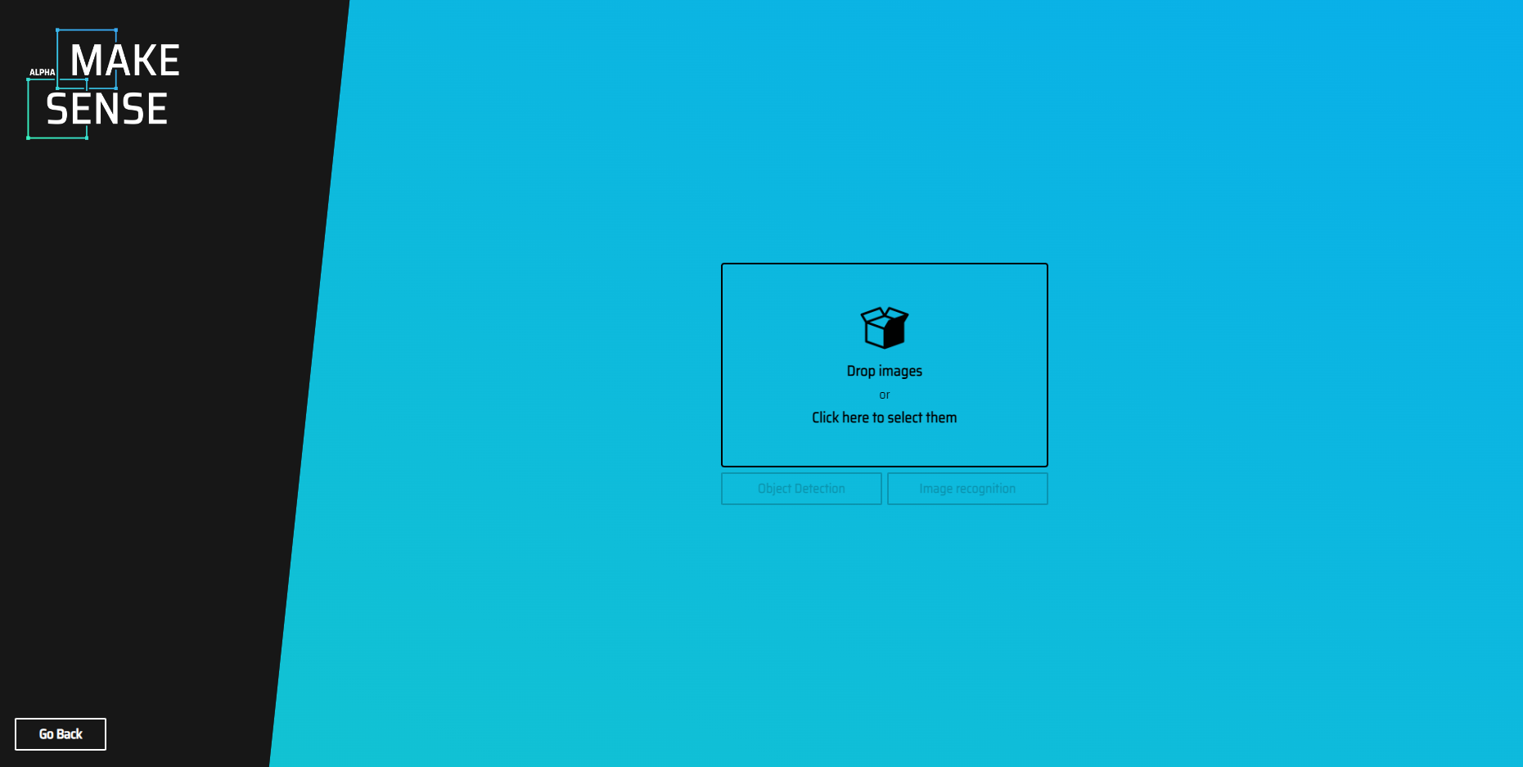

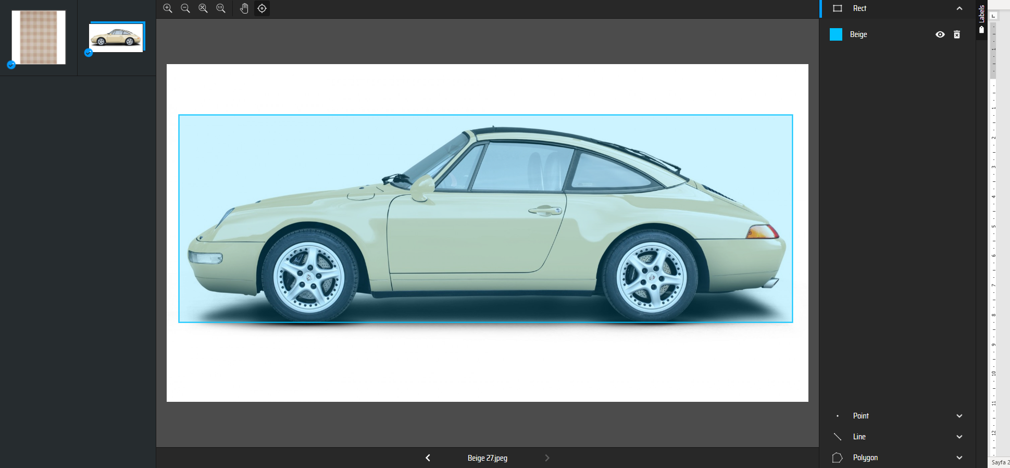

After labeling, labels and images were divided into two as train and validation. Here, 80% of the images and labels were allocated as test and 20% as validation.

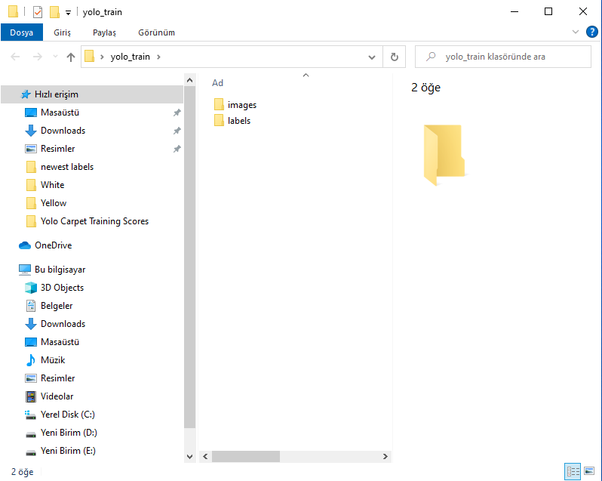

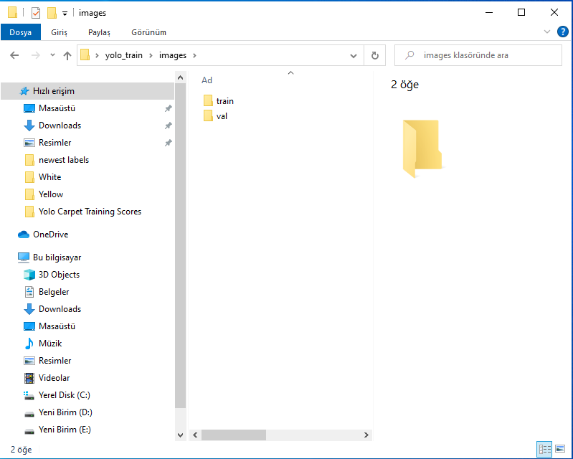

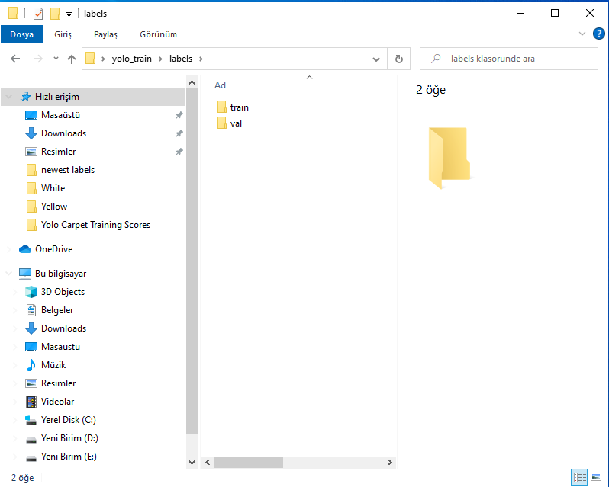

**2. Modelling**

The YOLOv5 GitHub repositor was used to set up the model. This respository was opened via Google Colab and the necessary downloads were made for the model. Then, the coco128.yaml file, which will make the necessary classification for the model, has been edited as follows.

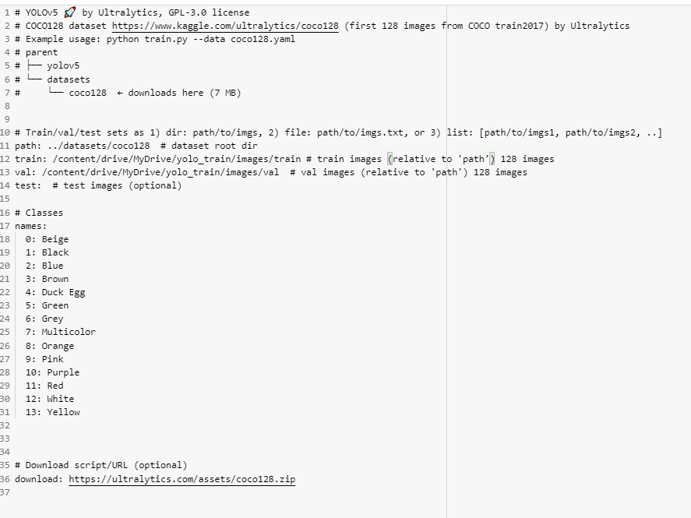

After editing the Coco128.yaml file, the necessary validation process for the model was performed. Along with this, the model recognized which object categories be detected.

!python val.py --weights yolov5s.pt --data coco128.yaml --**img** 640 --half

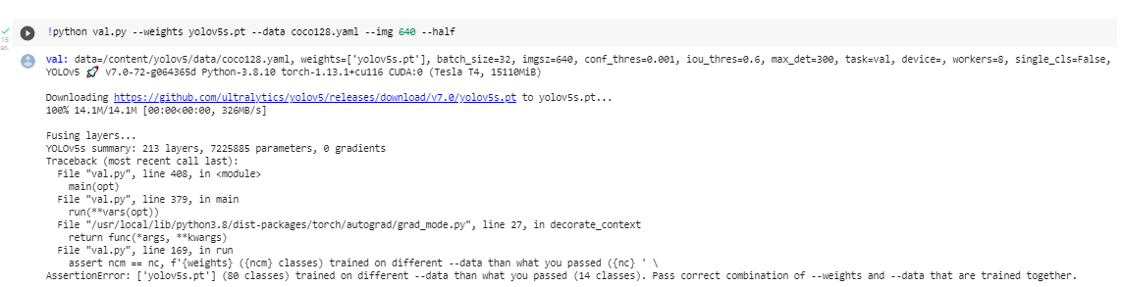

The model was trained with the following code block.

!python train.py --img 640 --batch 16 --epochs 70 --data coco128.yaml --weights yolov5s.pt --cache

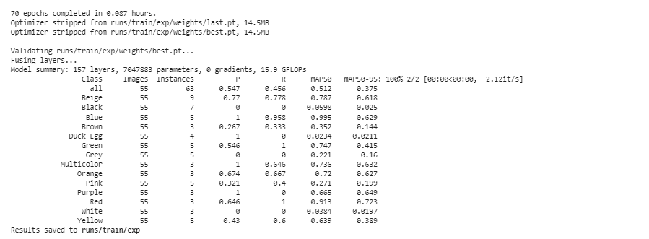

**3. Model Testing**

The detect command was used to see how well the model could detect. Below, we have seen that the model predicts beige color for a product in the orange category.

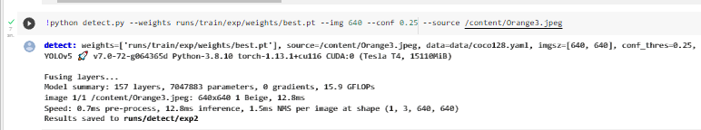

**4.Model Evaluation**

The model achieved an average confidence score of 0.42. This means that our model has difficulty distinguishing between colors. The conclusion to be drawn from here is the distinction made according to the colors of the carpets; does not give good predictive power to the model.

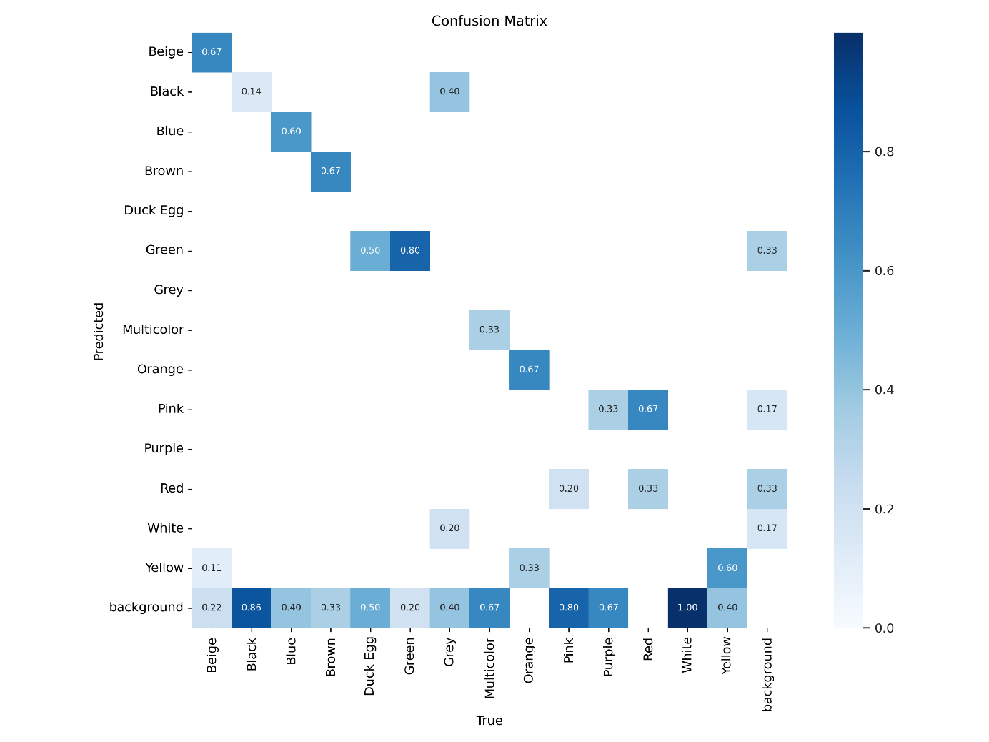

**Classification of Rugs based on Styles**

In this model, we applied *YOLOv5* to classify rugs based on the styles defined on the company’s website. Among them we selected 8 classes:

1-Bordered 5-Oriental

2-Doormats 6-Round

3-Faux Fur 7-Shaggy

4-Geometric 8-Striped

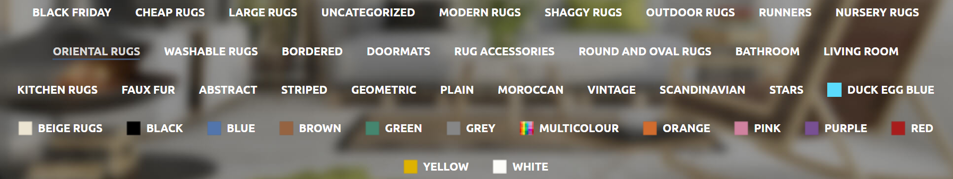

After downloading rugs from each category, they were labeled through *Makesense.ai*. In this model, we used 147 photos in total by separating them into the train (115) and validation (32) sets. Also, we saved a few photos and two YouTube videos to test our model.

We trained our model with 200 epochs and 8 batch sizes.





Although the overall train score is satisfactory, to receive a higher score, the model can be reset by using more samples, especially for Faux Fur and Shaggy classes.

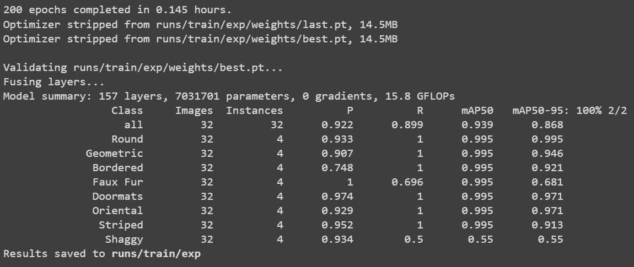

Test results are shown below:

**1. Faux Fur:**

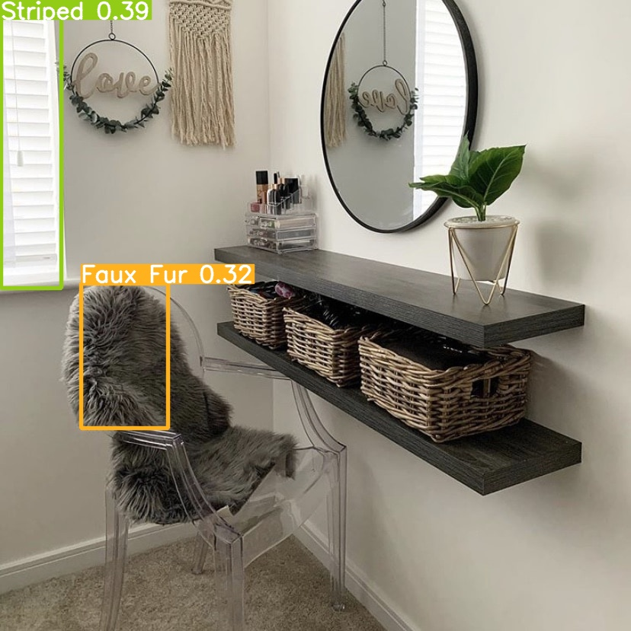

**2. Geometric:**

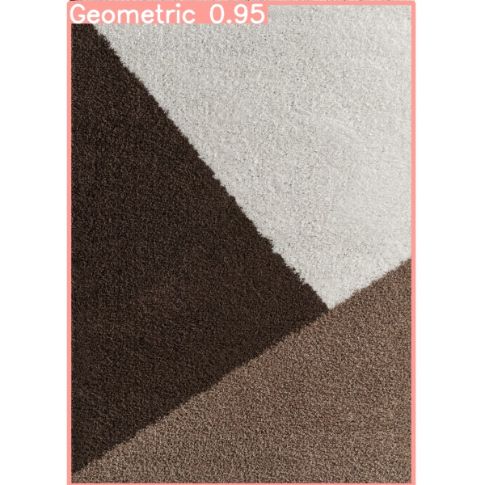

**3.**

**Doormats:**

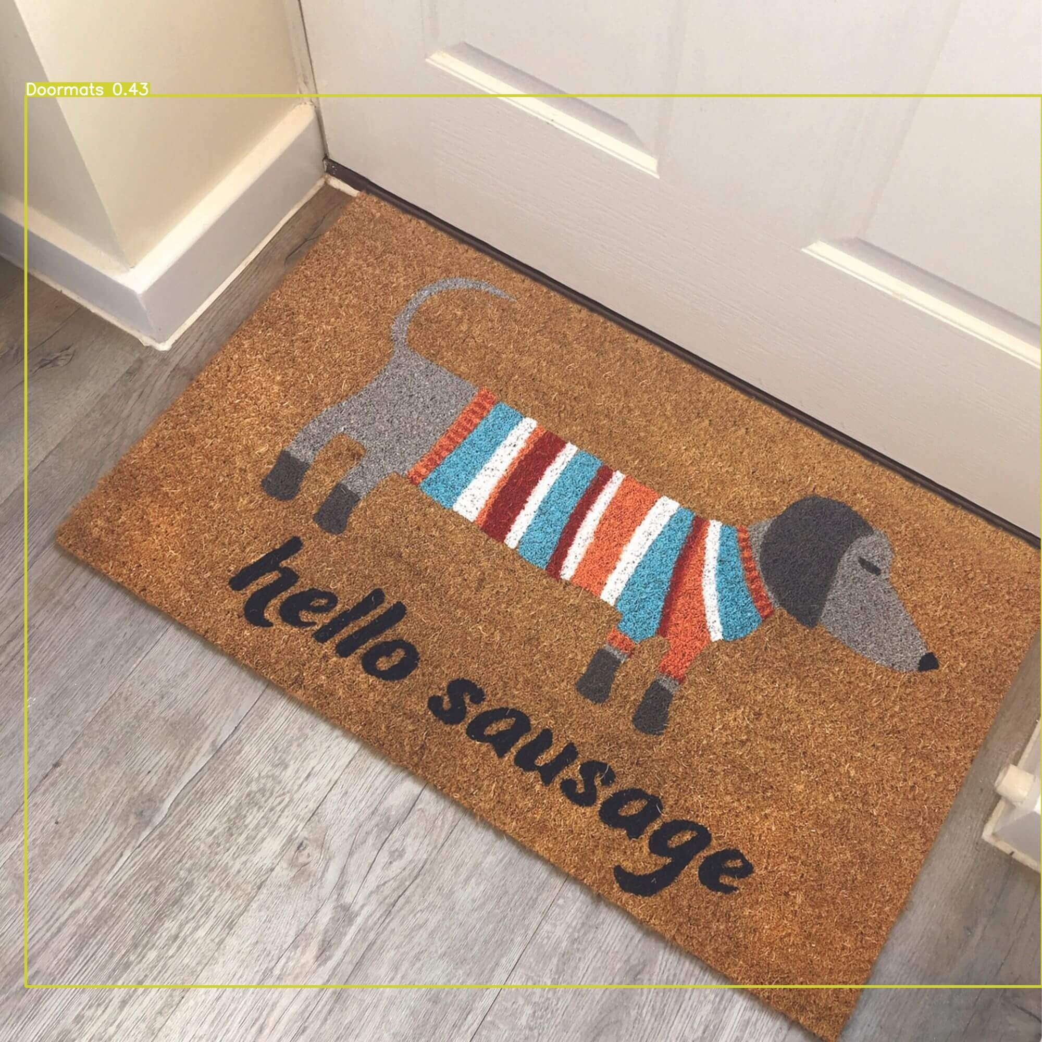

**4. Oriental:**

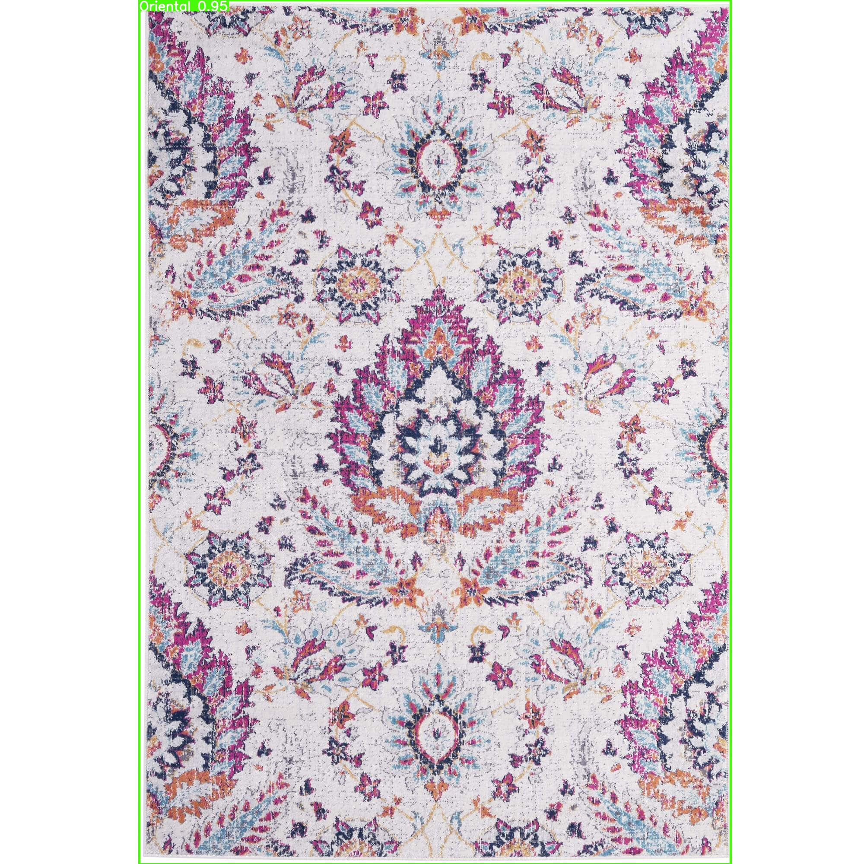

**5. Round:**

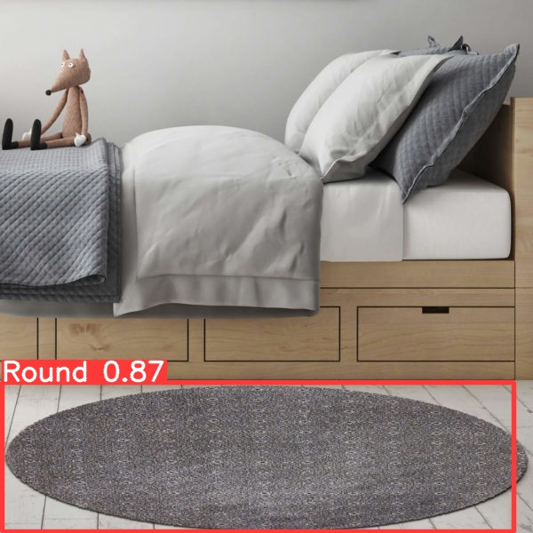

**6. Shaggy:**

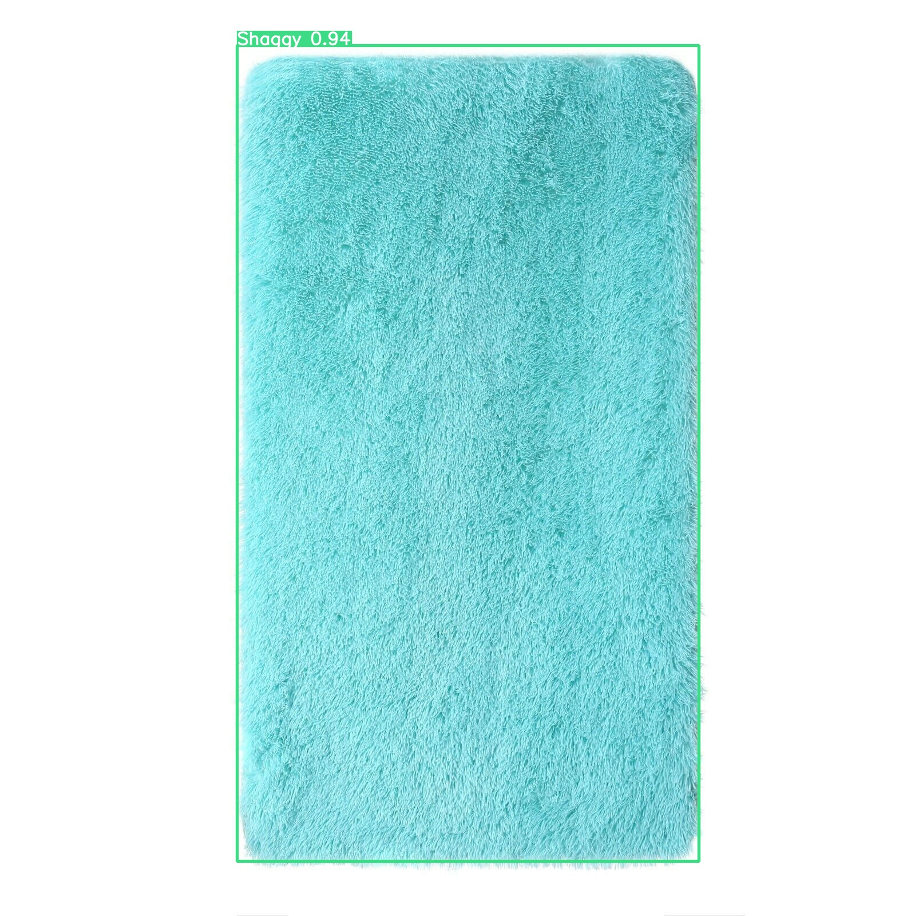

**Internship Computer Vision Report**

We want to make an app for a company. The purpose of making an app is that if the company wants to physically open a store, they can use our app.

Our app can be used in two ways.

1. When a customer comes to the store, the employee will be able to give the customer detailed information about the carpet. The employee will open the app on the phone and point it at the carpet the customer wants. Our model will recognize the carpet and show the carpet category and detailed features about the carpet. The employee will present these features to the customer. We expect the customer to be satisfied with this detailed and accurate information.
2. Bir başka kullanım amacı olarak, eğer mağaza çok büyük olursa, mağazaya giren müşteriler uygulamayı Google Play ve AppStore’dan indirip kullanabilirler.

Mağaza içinde dolaşırkenö beğendikleri halıyı APP’e gösterip o halı hakkında detaylı bilgiler alabilecekler.

Müşterilerin APP’i indirmesini çekici hale getirmek için, APP içinde halıyı beğen butonu konulabilir ve müşteri halıyı APP’e gösterdikten sonra beğen butonuna basabilir. APP ile halı beğenen müşterilere ekstra indirimler sunulabilir.

Bu şekilde Firma mağaza içinde daha az çalışan çalıştırabilir.

Modelimizin genel taslağı bu şekilde olacaktır.

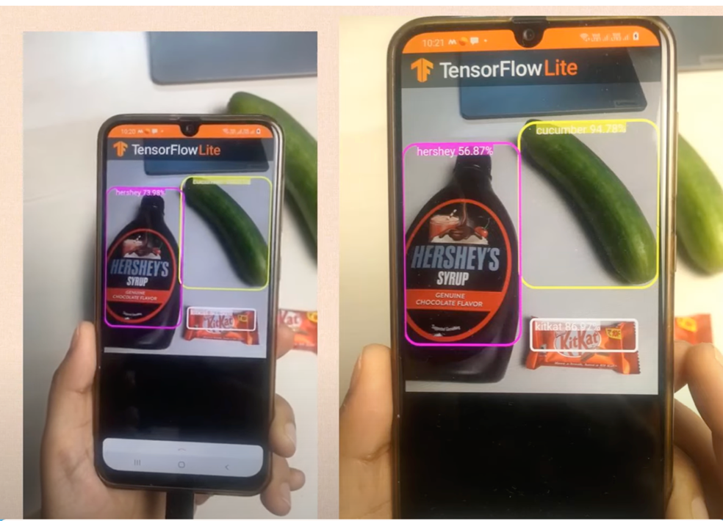

**Model-related phases**

1. I downloaded a total of 149 carpet images from the website and categorized them into 16 different categories

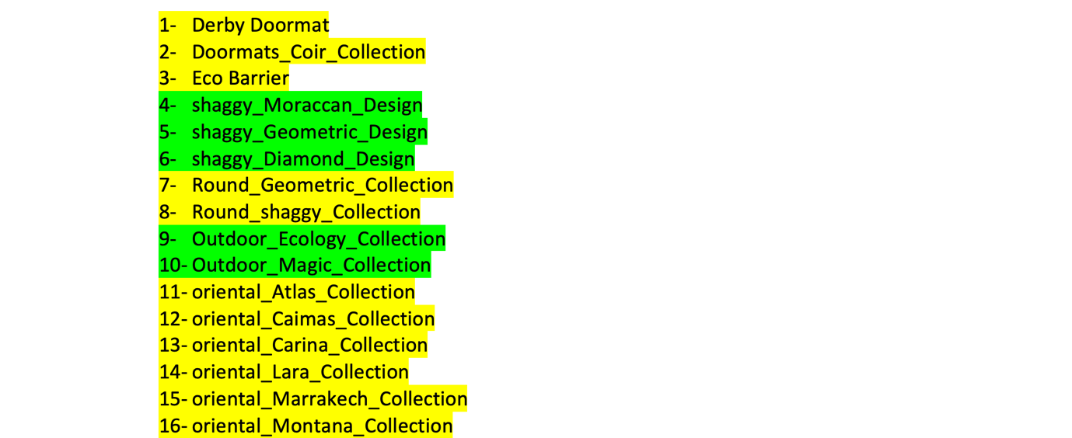

1. I did the labeling through the Roboflow site. When I downloaded the images from the site, I had previously determined which category I was going to use. When I downloaded the images, I gave each image the category names I had determined. This way, when the model makes predictions, I can easily see whether it guessed correctly or not by looking at these names.

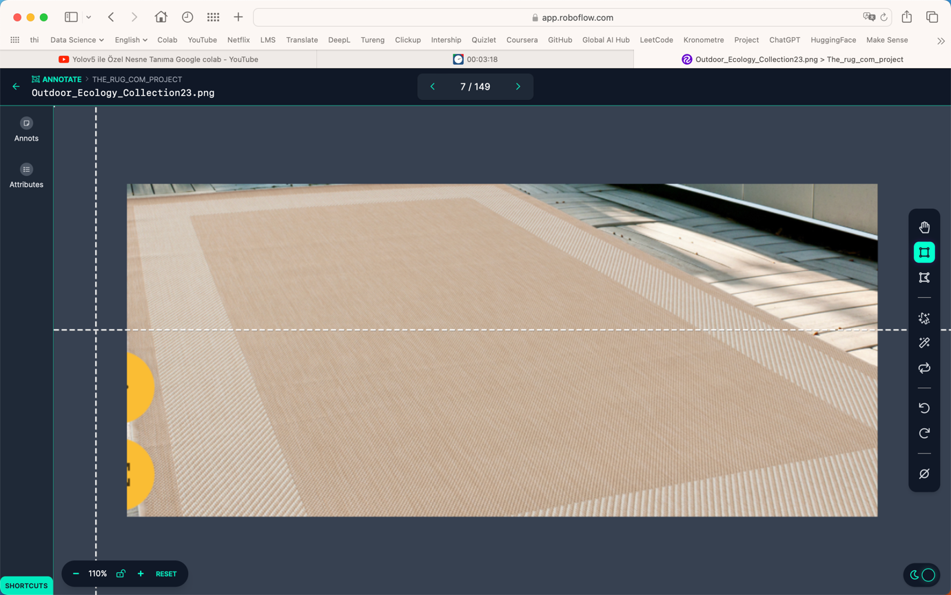

1. This is how Roboflow allocated the number of images.

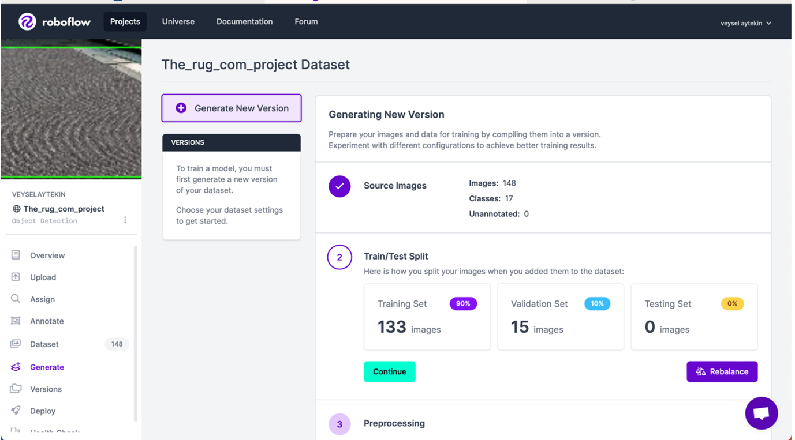

**We are training our YOLO5 model.**

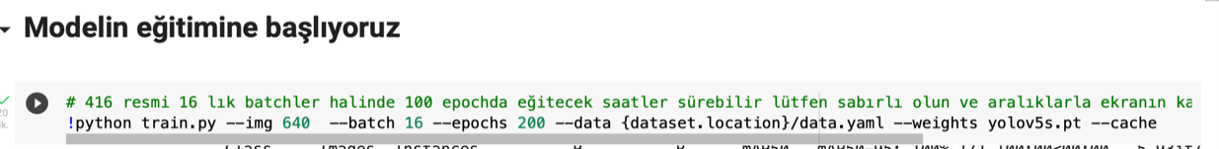

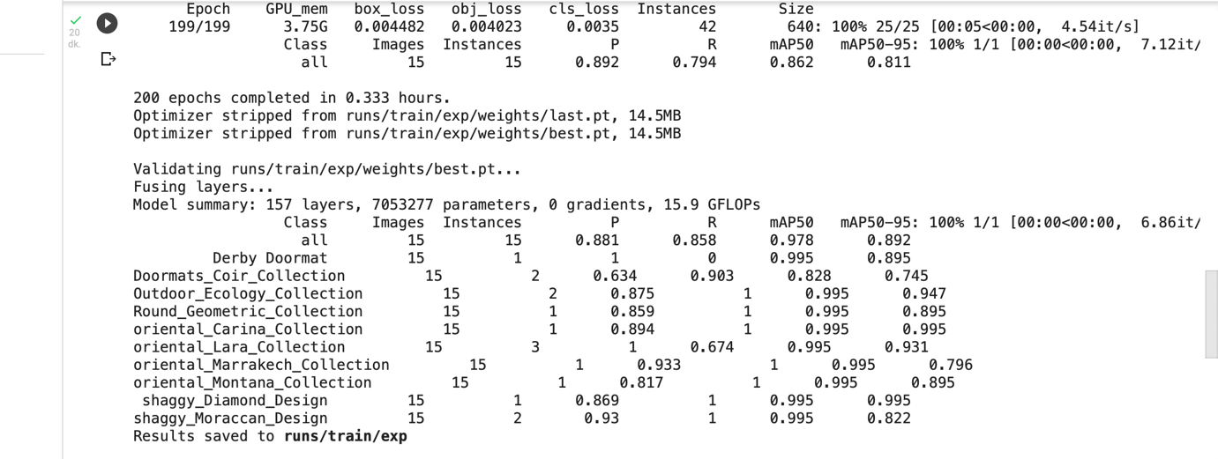

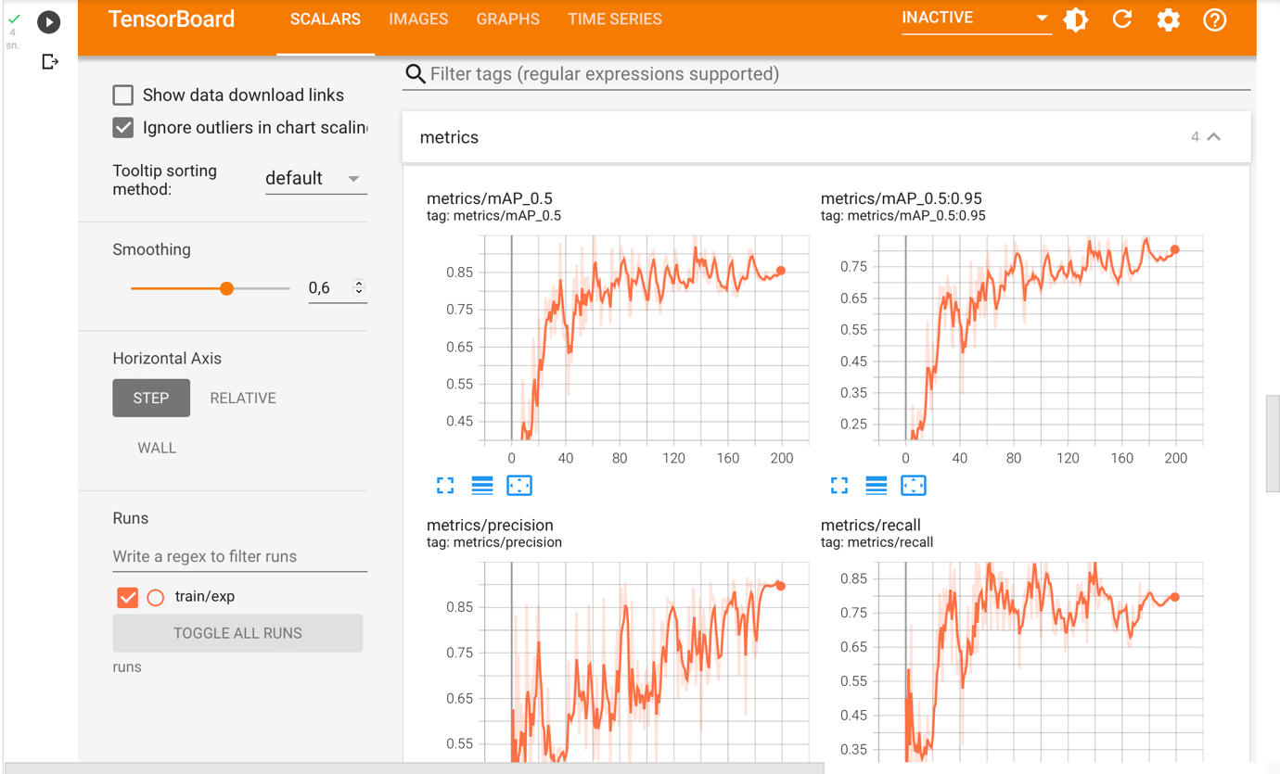

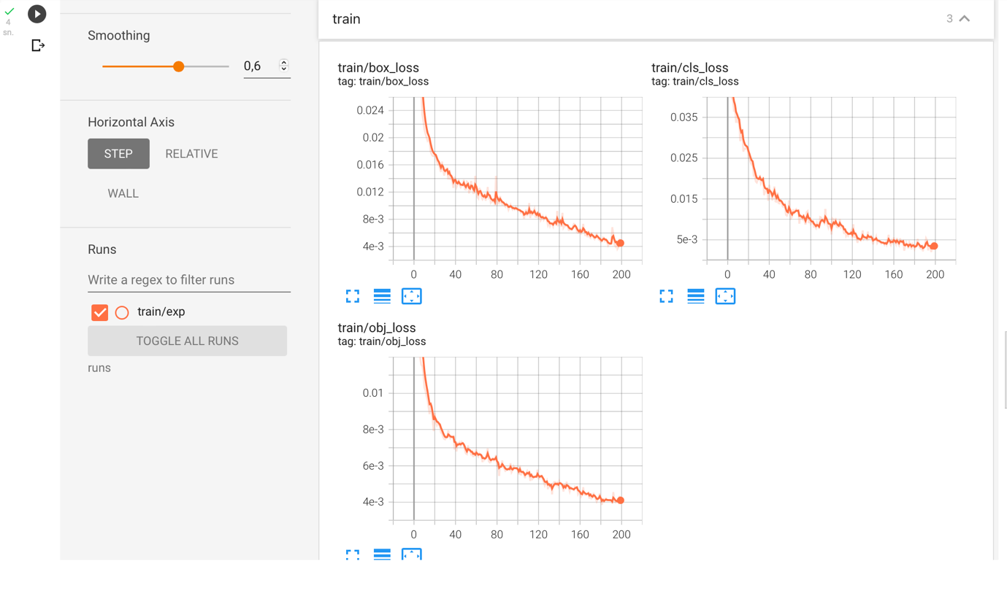

**OUR PREDICTION**

